Assignment 8 : Docker
One Git repo
Three branches:
- main (or master)
- 2026Q1
- 2026Q2
Jenkins Master (JM)
3 Jenkins Slaves
Each slave has Docker installed Use docker bind mount
Deploy:
- Slave1 → main branch
- Slave2 → 2026Q1
Slave3 → 2026Q2
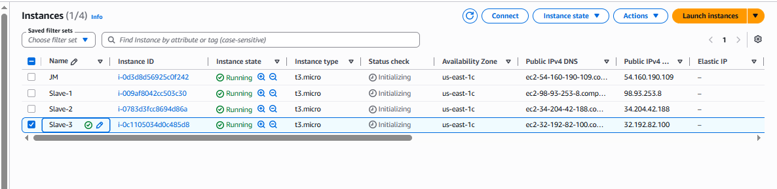

Install java in all machine :
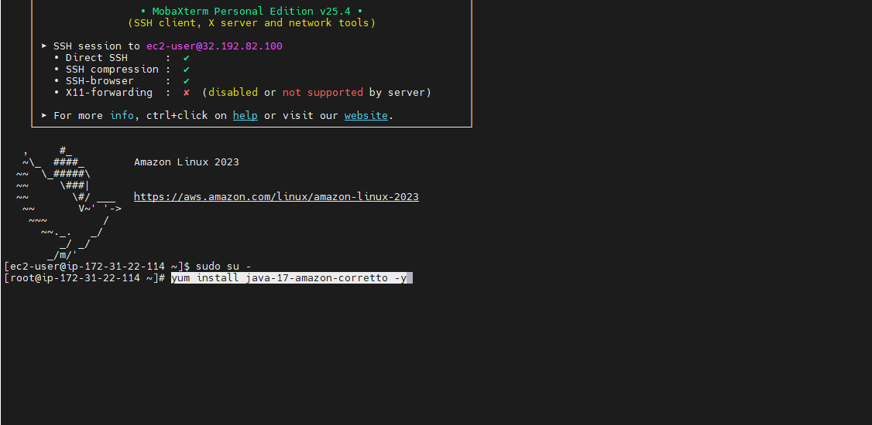

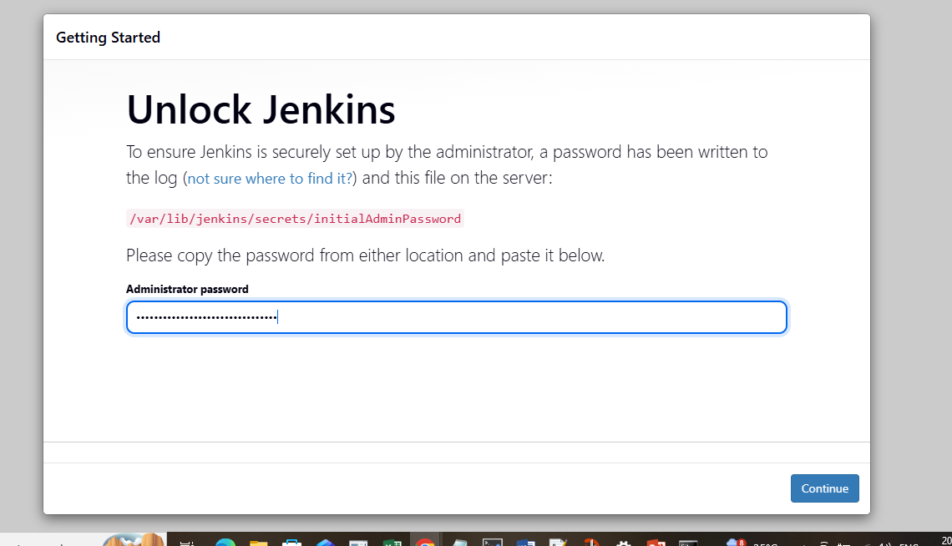

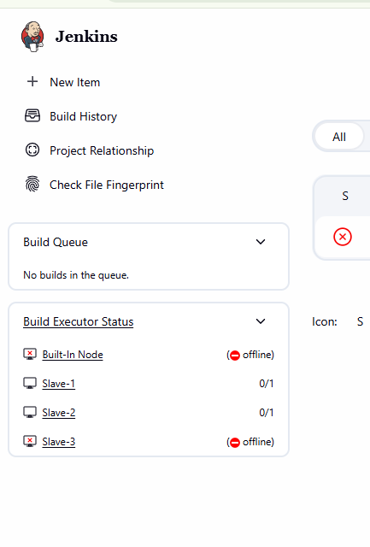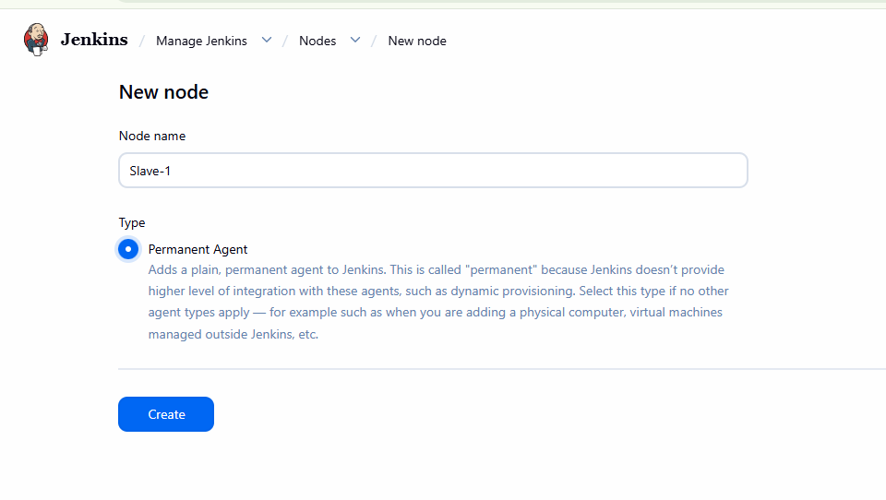

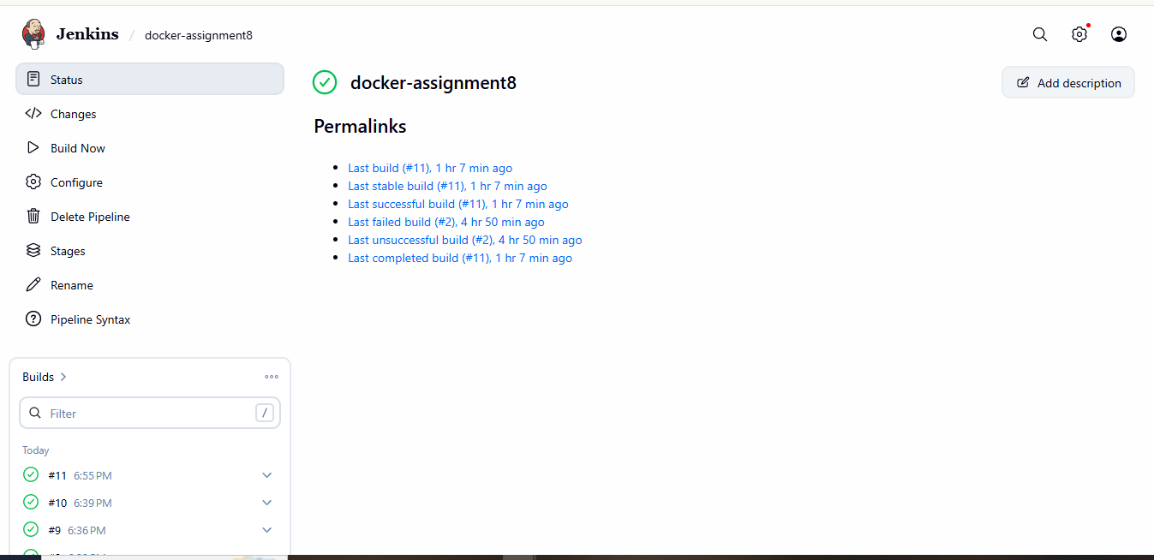

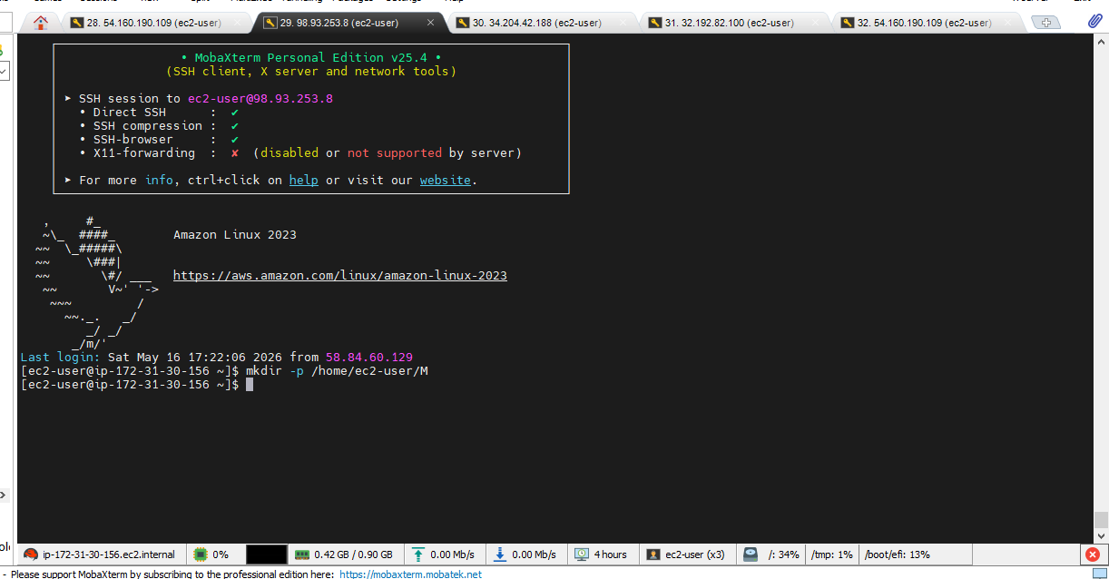
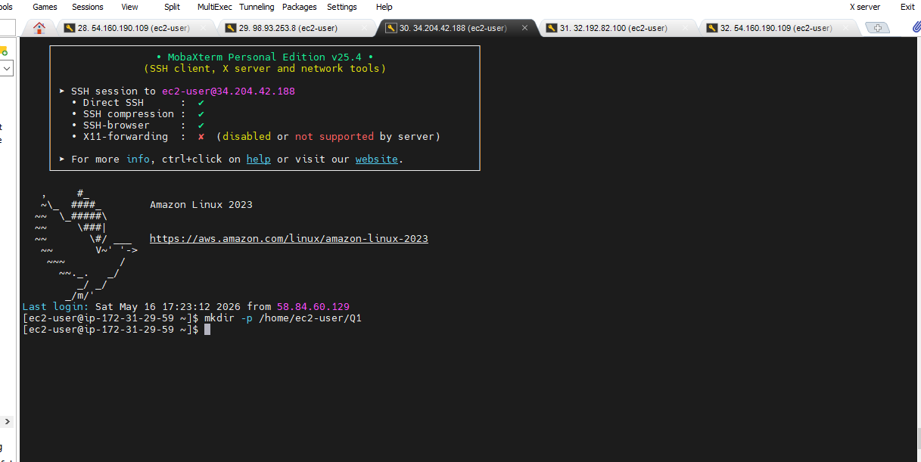
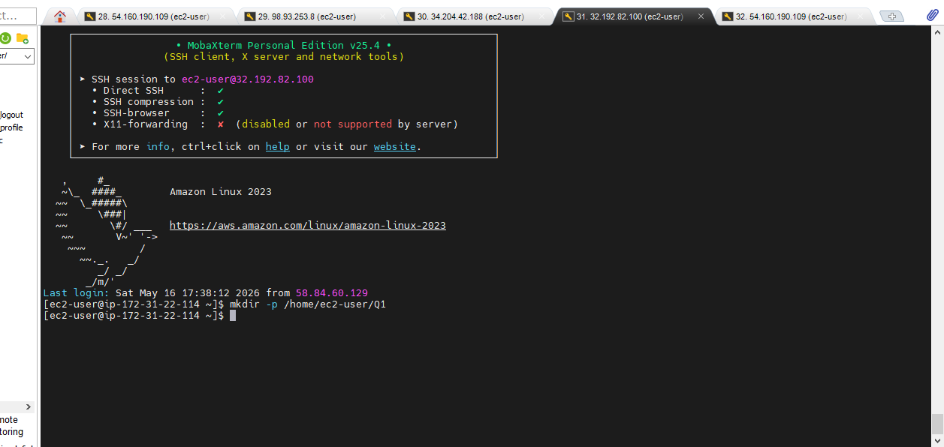
Slave 1 :
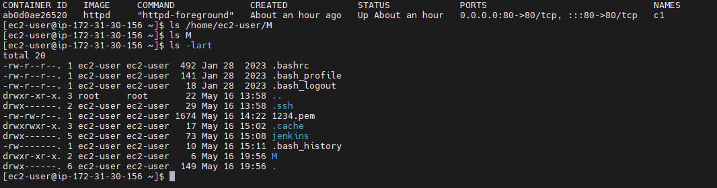

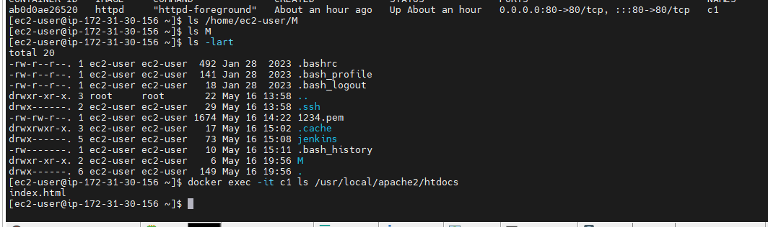
http:// http://98.93.253.8:80
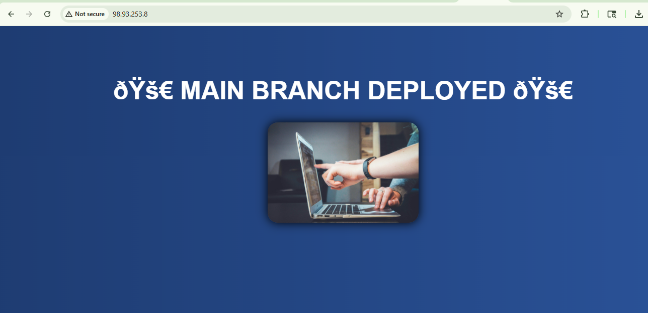

Slave:2
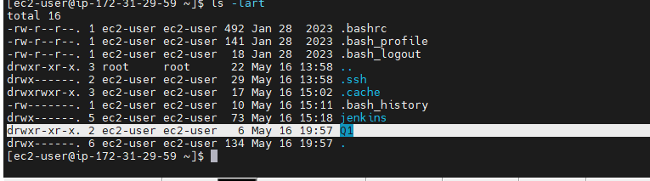

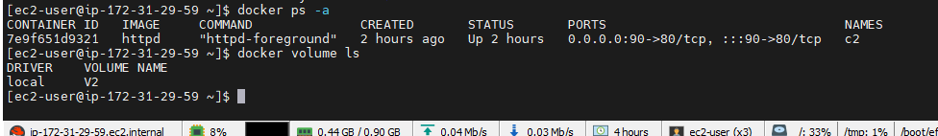

http://slave2ip :90
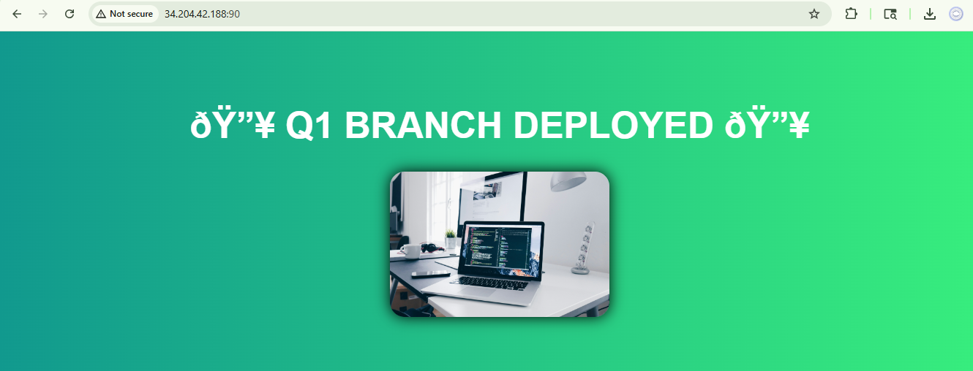

slave3 :
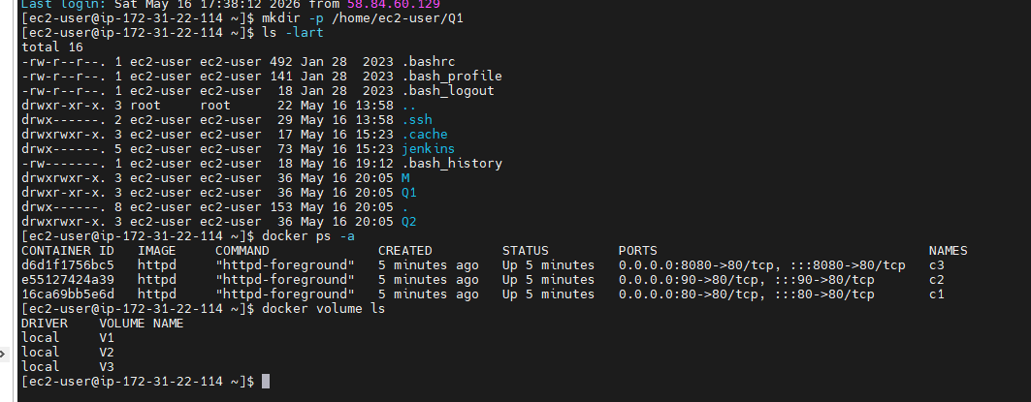
http://slave3Ip :8080
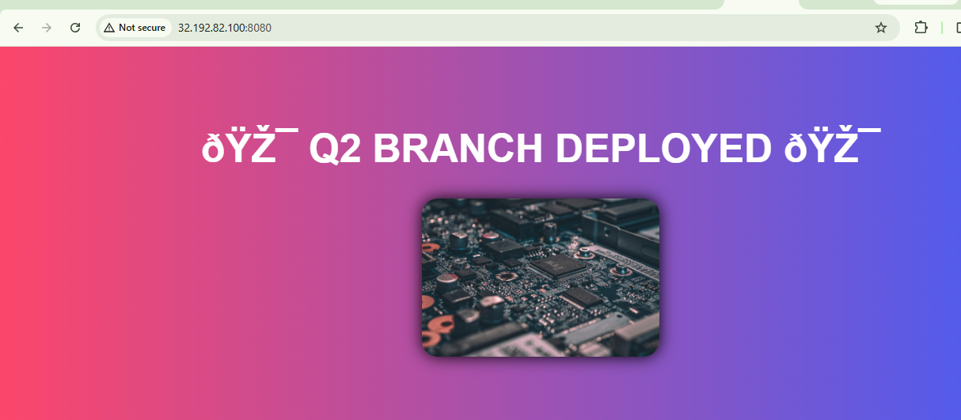

Script :
pipeline {

agent any

stages {

// ================= MAIN =================

stage('MAIN') {

steps {

sh '''

rm -rf repo
git clone -b main https://github.com/Pallavi-250598/Repo-1.git repo

cp -r repo/* /home/ec2-user/M/

docker rm -f c1 || true

docker run -dit --name c1 -p 80:80 -v /home/ec2-user/M:/usr/local/apache2/htdocs httpd

'''
}
}

// ================= Q1 =================

stage('Q1') {

steps {

sh '''

rm -rf repo
git clone -b 2026Q1 https://github.com/Pallavi-250598/Repo-1.git repo

cp -r repo/* /home/ec2-user/Q1/

docker rm -f c2 || true

docker run -dit --name c2 -p 90:80 -v /home/ec2-user/Q1:/usr/local/apache2/htdocs httpd

'''
}
}

// ================= Q2 =================

stage('Q2') {

steps {

sh '''

rm -rf repo
git clone -b 2026Q2 https://github.com/Pallavi-250598/Repo-1.git repo

cp -r repo/* /home/ec2-user/Q2/

docker rm -f c3 || true

docker run -dit --name c3 -p 8080:80 -v /home/ec2-user/Q2:/usr/local/apache2/htdocs httpd

'''
}
}
}
}

